Marine life plays a very important role in our lives. Not only do they contribute to the Earth’s climate, but they are also a huge source of medicine for us. One main medicinal marine organism is the horseshoe crab. Their medicinal purpose is not in the form of a drug, but serves as a means of making sure that our vaccines are safe. Horseshoe crabs are of the phylum arthropoda. They have crab in their name, but they are not crustaceans and make up their own class. With their features, they are more closely related to spiders and scorpions. Back to their medicinal purpose, it is their blood that is so valuable to medicine. Their blood is a distinct blue color, because they use hemocyanin to transport oxygen around the body, not hemoglobin like us. Vertebrates, like us, have white blood cells in our bloodstream to fight off bacteria and pathogens. Invertebrates like horseshoe crabs have amebocytes instead. When the amebocytes come into contact with a pathogen/endotoxin, it releases a chemical that causes the local blood to clot. This allows scientists to test a vaccine sample for bacteria by inserting their blood in the sample. If it clots, there is bacteria present.
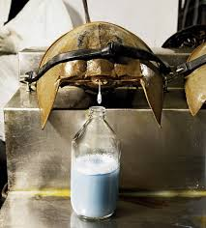
The other marine organism I found to have an important medicinal purpose is the sponge. Sponges are of the phylum porifera, and are some of the most primitive creatures out there. Their cell based organization gives their cells different functions, but they do not form tissues. They also contain many biologically active natural products, which has piqued the interest of experts in recent years. Many of these products that the sponges carry show a wide range of pharmacological traits, such as anticancer, antifungal, anthelmintic, antiprotozoal, anti inflammatory, immunosuppressive, neurosuppressive, and antifouling traits.
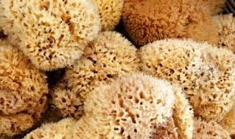
Dkjsdj nh uihui ui guyb uib uib uib iubiu bub u bu bu bu bu b ub ub ub u u b ub ub ub hv hvbhjvyu vh v hub h bj bu bu b ub ub ub h gbj bu bu bu b ub ib u bhv tyc rv tc rc rd crv hb iygib u i byu vuy b uyb iu b ub ijb u biu vt vbuh v uyb u biu b ub iub u bi jb ubn iu bio nbiu b uib ub iub i b ib i biu g ib i i bi ub i bui b iub i hbi b iub i bui bi ubi b iug iu bu b uib b iu biu biu b iub iub uib 8u bui biu biu b uib iub ui biu bui bui bui bu ib iubiu b ub

